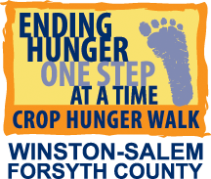
HOW TO SIGN UP WALKERS/TEAM MEMBERS

- PRIOR TO SIGNING UP WALKERS/TEAM MEMBERS
  - Set up online team page at www.crophungerwalk.org
  - Prepare Walker Envelopes
    - Fill in the top portion of the envelope:
    - Walk Name: Winston-Salem/Forsyth County
    - Walk Date: October 21, 2018
    - Congregation/School/Organization
Please note: Several teams in the area have identical names, so be sure to put the full name of your team and town so we can give credit to the right team! (Examples: First Baptist Church – WS or First Baptist Church – Clemmons. Mt. Tabor High School or Mt. Tabor UMC.)
    - Fill in the shaded portion:
      - Team Captain/Recruiter Name
      - Team Captain/Recruiter Email
      - Team Captain/Recruiter Phone
    - Make copies of footprints (if using) and cut them out.
    - Make copies of Walker Resources to give to walkers when they sign up.
      - Receipts for Cash Donations
      - Directions
      - Route Map
      - Consent Forms for multiple walkers using the same envelope
      - Info Sheet with walk day details for your team (optional, created by you)

- SIGNING UP WALKERS/TEAM MEMBERS
  - Give an envelope to each walker, family, or group walking together. An envelope is not necessary if walker or group is only acquiring donations online.
  - Record the number of the envelope given to walker(s) on the Recruiter’s Packet.
  - Show walkers where to enter the following information:
    - Name, Address, Email, Phone, Number of walkers represented by the envelope.
  - Show walkers where to sign “Statement of Consent” at the bottom. If child, parent will sign. If multiple walkers using the same envelope, give “Consent Form for Multiple Walkers” and instruct to have each walker sign and bring on walk day.
  - Encourage walker to join your team at the Online Participant Fundraising Site.
  - Tell walkers how they can earn a FREE Winston-Salem/Forsyth County CROP Hunger Walk t-shirt:
    - By collecting $100 in donations - for adults
    - By collecting $50 in donations – for those 12 and under
  - NEW INCENTIVE: Collect $150 in donations online and receive a FREE national CROP Hunger Walk
t-shirt. Start a team online and register ten team members online and receive a FREE national cap.

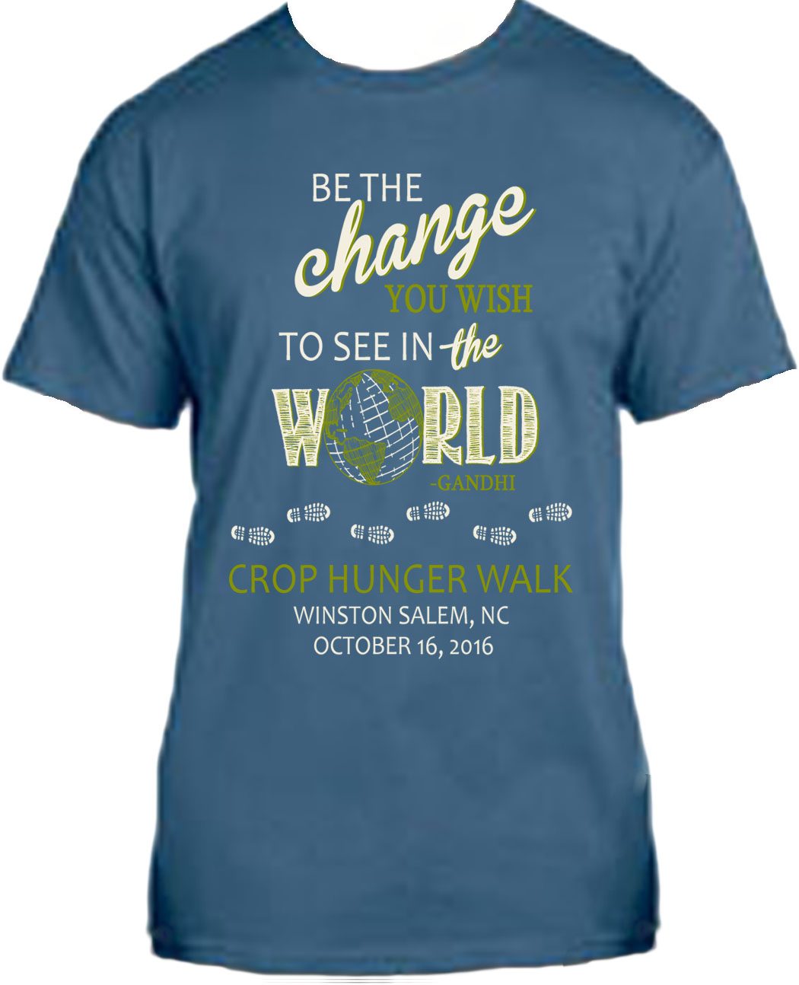

WS/FC T-shirt Design
Earn a FREE T-shirt
- By collecting $100 in donations – for adults
    - By collecting $50 in donations – for ages 12 and under

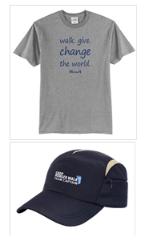
National T-shirt Design
National Cap Design
- Earn a FREE national t-shirt by collecting $150 in donations online
- Earn a FREE national cap by starting a team online and registering ten team members online

