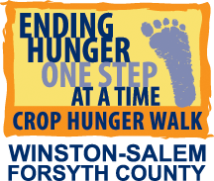
2018 CHILDREN’S ACTIVITIES ON WALK DAY
PLANTING SEEDS OF COMPASSION AND CARING

Four stations at Bailey Park will help our younger walkers learn about the challenges and difficulties children in other countries – and some children in our local community -- face in living a life we call normal. Each station will focus on a different topic – Health, Education, Hunger, and Water – to help children (and adults, too!) learn what others experience on a daily basis.

PASSPORT

Sign up for your very own passport at Bailey Park . While you are there, get your face painted with a CROP tatoo or other symbol marking your journey.
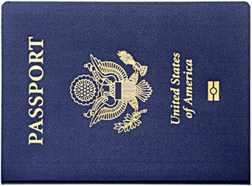
TRAVEL

Visit each station and learn about a different challenge faced daily by others. Learn what you can do with your CROP gifts to help change life for our local and global family. Don’t forget to have your passport stamped at each station after your experience.

RETURN

Have your passport stamped at each station. If you have traveled to all stations, receive a small prize that lets other walkers know you have completed your journey.

SHARE

Tell other walkers and friends at home what you have learned. Encourage them to make a donation or gift that will help our friends here and around the world live a better life. It’s never too late to “Be the change you want to see in the world.”

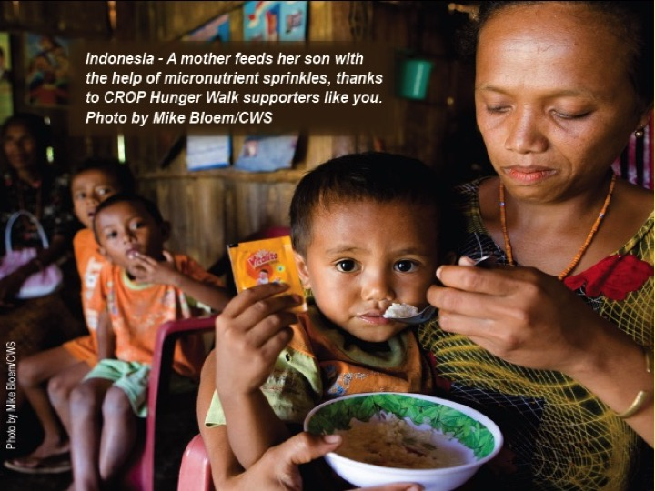
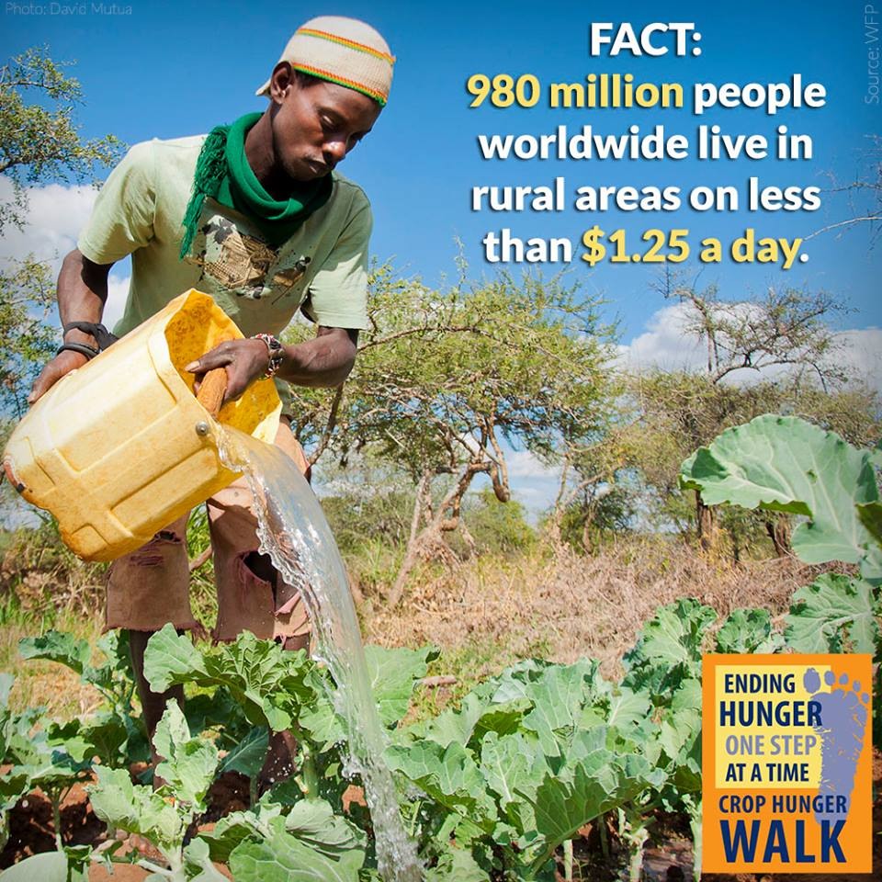
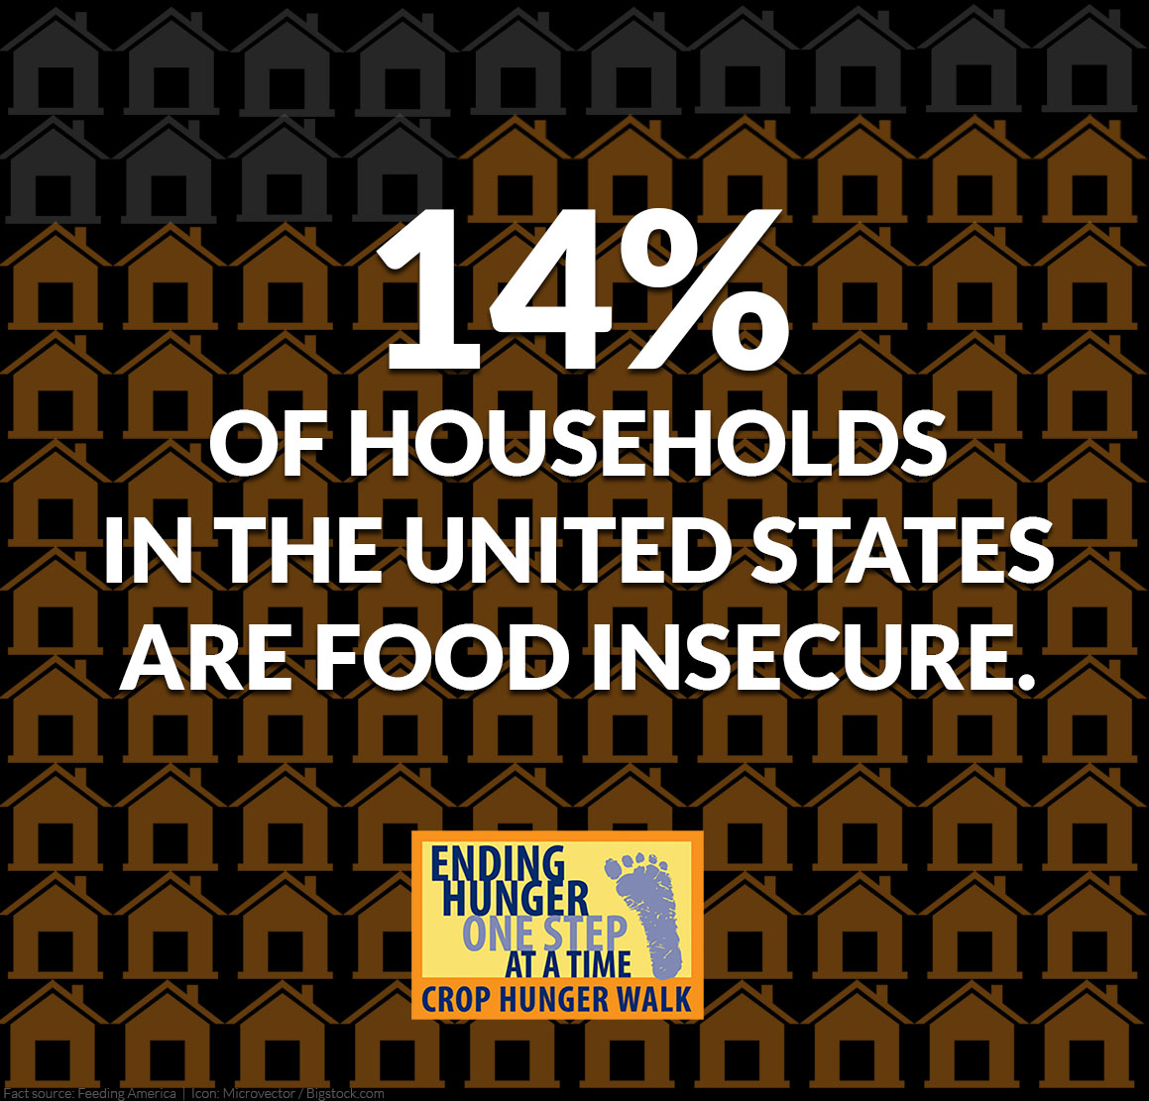
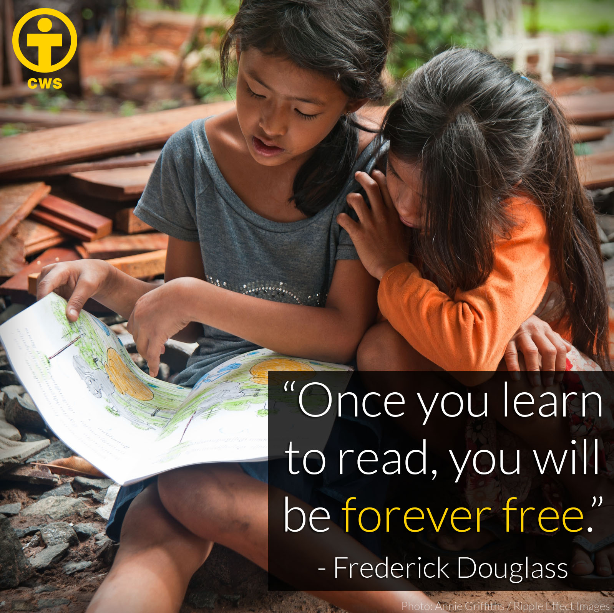

EDUCATION

HEALTH

WATER

HUNGER

